Sentiment analysis in R
Sentiment analysis helps you extract an author's feelings towards a subject. This exercise will give you a taste of what's to come!
We created text_df representing a conversation with person and text columns.
Use qdap's polarity() function to score text_df. polarity() will accept a single character object or data frame with a grouping variable to calculate a positive or negative score.
In this example you will use the magrittr package's dollar pipe operator %$%. The dollar sign forwards the data frame into polarity() and you declare a text column name or the text column and a grouping variable without quotes.
text_data_frame %$% polarity(text_column_name)

To create an object with the dollar sign operator:
polarity_object <- text_data_frame %$%
polarity(text_column_name, grouping_column_name)

More specifically, to make a quantitative judgement about the sentiment of some text, you need to give it a score. A simple method is a positive or negative value related to a sentence, passage or a collection of documents called a corpus. Scoring with positive or negative values only is called "polarity." A useful function for extracting polarity scores is counts() applied to the polarity object. For a quick visual call plot() on the polarity() outcome.
Instructions
- Examine the text_df conversation data frame.
- Using %$% pass text_df to polarity() along with the column name text without quotes. This will print the polarity for all text.
- Create a new object datacamp_conversation by forwarding text_dfwith %$% to polarity(). Pass in text followed by the grouping person column. This will calculate polarity according to each individual person. Since it is all within parentheses the result will be printed too.
- Apply counts() to datacamp_conversation to print the specific emotional words that were found.
- plot() the datacamp_conversation.
# Examine the text data
text_df

# Calc overall polarity score
text_df %$% polarity(text)

# Calc polarity score by person
(datacamp_conversation <- text_df %$% polarity(text, person))

# Counts table from datacamp_conversation
counts(datacamp_conversation)

# Plot the conversation polarity
plot(datacamp_conversation)

TM refresher (I)
0xp
In the Text Mining: Bag of Words course you learned that a corpus is a set of texts, and you studied some functions for preprocessing the text. To recap, one way to create a corpus is with the functions below. Even though this is a different course, sentiment analysis is part of text mining so a refresher can be helpful.
- Turn a character vector into a text source using VectorSource().
- Turn a text source into a corpus using VCorpus().
- Remove unwanted characters from the corpus using cleaning functions like removePunctuation() and stripWhitespace() from tm, and replace_abbreviation() from qdap.
In this exercise a custom clean_corpus() function has been created using standard preprocessing functions for easier application.
clean_corpus() accepts the output of VCorpus() and applies cleaning functions. For example:
processed_corpus <- clean_corpus(my_corpus)

Instructions
Your R session has a text vector, tm_define, containing two small documents and the function clean_corpus().
- Create an object called tm_vector by applying VectorSource() to tm_define.
- Make tm_corpus using VCorpus() on tm_vector.
- Use content() to examine the contents of the first document in tm_corpus.
  - Documents in the corpus are accessed using list syntax, so use double square brackets, e.g. [[1]].
- Clean the corpus text using the custom function clean_corpus() on tm_corpus. Call this new object tm_clean.
- Examine the first document of the new tm_clean object again to see how the text changed after clean_corpus() was applied.
--
# clean_corpus(), tm_define are pre-defined
clean_corpus
tm_define

# Create a VectorSource
tm_vector <- VectorSource(tm_define)

# Apply VCorpus
tm_corpus <- VCorpus(tm_vector)

# Examine the first document's contents
content(tm_corpus[[1]])

# Clean the text
tm_clean <- clean_corpus(tm_corpus)

# Reexamine the contents of the first doc
content(tm_clean[[1]])

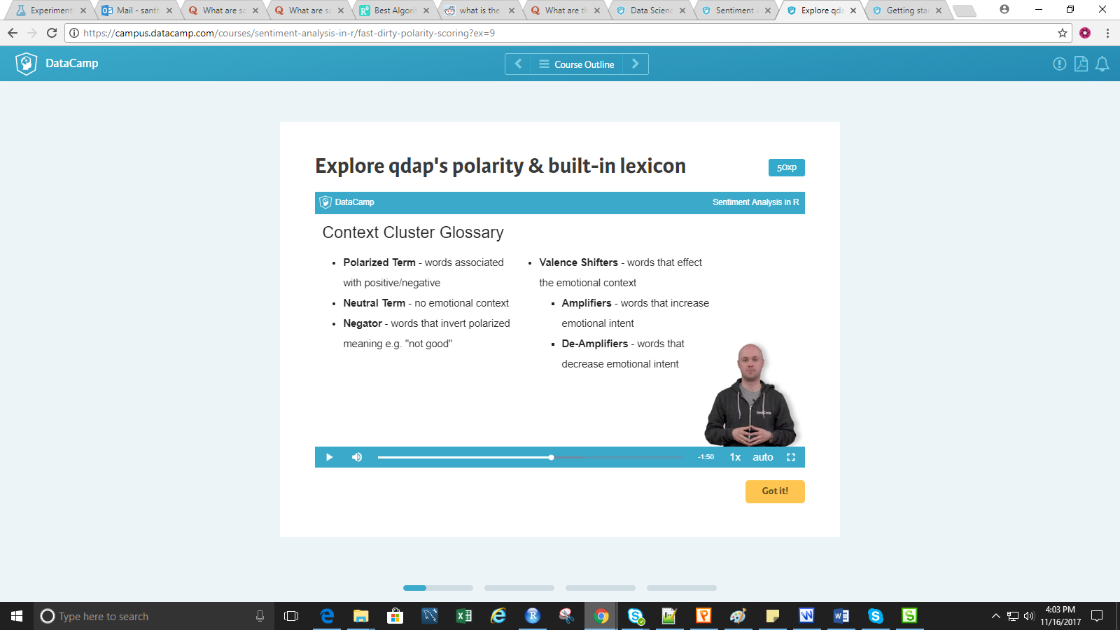

Bing tidy polarity: Simple example
100xp
The Bing lexicon labels words as positive or negative. The next three exercises let you interact with this specific lexicon. Instead of using filter() to extract a lexicon this exercise uses get_sentiments() which accepts a string such as "afinn", "bing", "nrc", or "loughran".
Now that you understand the basics of an inner join, let's apply this to the "Bing" lexicon. Keep in mind the inner_join() function comes from dplyr and the sentimentsobject is from tidytext.
The inner join workflow:
- Obtain the correct lexicon using either filter() or get_sentiments().
- Pass the lexicon and the tidy text data to inner_join().
- In order for inner_join() to work there must be a shared column name. If there are no shared column names, declare them with an additional parameter, by equal to c with column names like below.
object <- x %>%
inner_join(y, by = c("column_from_x" = "column_from_y")

- Perform some aggregation and analysis on the table intersection.
Instructions
We've loaded ag_txt containing the first 100 lines from Agamemnon and ag_tidy which is the tidy version.
- For comparison, use polarity() on ag_txt.
- Get the "bing" lexicon by passing that string to get_sentiments().
  - Perform an inner_join() with ag_tidy and bing.
The word columns are called "term" in ag_tidy and "word" in the lexicon, so you need to specify the by argument.
  - Call the new object ag_bing_words.
- Print ag_bing_words, and look at some of the words that are in the result.
- Pass ag_bing_words to count() of sentiment using the pipe operator, %>%. Compare the polarity() score to sentiment count ratio.

SAmple Sentiment analysis

1 . Load data

In this short exercise you will load and examine a small corpus of property rental reviews from around Boston. Hopefully you already know read.csv() which enables you to load a comma separated file. In this exercise you will also need to specify stringsAsFactors = FALSE when loading the corpus. This ensures the reviews are character classes, not factors. This may seem mundane but the point of this chapter is to get you doing an entire workflow from start to finish so let's begin with data ingestion!
Next you simply apply str() to review the data frame's structure. It is a convenient function for compactly displaying initial values and class types for vectors.
Lastly you will apply dim() to print the dimensions of the data frame. For a data frame, your console will print the number of rows and the number of columns.
Other functions like head(), tail() or summary() are often used for data exploration but in this case we keep the examination short so you can get to the fun sentiment analysis!

2. Quickly examine the basic polarity
When starting a sentiment project, sometimes a quick polarity() will help you set expectations or learn about the problem. In this exercise (to save time), you will apply polarity() to a portion of the comments vector while the larger polarity object is loaded in the background.
Using a kernel density plot you should notice the reviews do not center on 0. Often there are two causes for this sentiment "grade inflation." First, social norms may lead respondents to be pleasant instead of neutral. This, of course, is channel specific. Particularly snarky channels like e-sports or social media posts may skew negative leading to "deflation." These channels have different expectations. A second possible reason could be "feature based sentiment". In some reviews an author may write "the bed was comfortable and nice but the kitchen was dirty and gross." The sentiment of this type of review encompasses multiple features simultaneously and therefore could make an average score skewed.
In a subsequent exercise you will adjust this "grade inflation" but here explore the reviews without any change.
Instructions
- Create practice_pol using polarity() on the first six reviews as in bos_reviews$comments[1:6]
- Review the returned polarity object by calling practice_pol.
- Call summary() on practice_pol$all$polarity - this will access the overall polarity for all 6 comments.
- We've also loaded a larger polarity object for all 1000 comments. This new object is called bos_pol. Now apply summary() to the correct list element that returns all polarity scores of bos_pol.
- The sample code has a barplot and kernel density plot almost ready to print. However, you must enter the data frame representing all scores. Hint: in the previous step, polarity represents a column of this data frame.
# Practice apply polarity to first 6 reviews
practice_pol <- polarity(bos_reviews$comments[1:6])

# Review the object
practice_pol

# Check out the practice polarity
summary(practice_pol$all$polarity)

# Summary for all reviews
summary(bos_pol$all$polarity)

# Plot it
ggplot(bos_pol$all, aes(x = polarity, y = ..density..)) +
theme_gdocs() +
geom_histogram(binwidth = 0.25, fill = "#bada55", colour = "grey60") +
geom_density(size = 0.75)

Create a Polarity Based Corpora
100xp
In this exercise you will perform Step 3 of the text mining workflow. Although qdap isn't a tidy package you will mutate() a new column based on the returned polarity list representing all polarity (that's a hint BTW) scores. In chapter 3 we used a custom function pol_subsections which uses only base R declarations. However, in following the tidy principles this exercise uses filter() then introduces pull(). The pull()function works like works like [[ to extract a single variable.
Once segregated you collapse all the positive and negative comments into two larger documents representing all words among the positive and negative rental reviews.
Lastly, you will create a Term Frequency Inverse Document Frequency (TFIDF) weighted Term Document Matrix (TDM). Since this exercise code starts with a tidy structure, some of the functions borrowed from tm are used along with the %>% operator to keep the style consistent. If the basics of the tm package aren't familiar check out the Text Mining: Bag of Words course. Instead of counting the number of times a word is used (frequency), the values in the TDM are penalized for over used terms, which helps reduce non-informative words.
Instructions
- Review the polarity group with bos_pol$group. Note the average polarity scores are not centered at 0.
- Forward bos_reviews to mutate() and create a new column polarity equal to bos_pol$all$polarity.
- Forward bos_reviews_with_pol to filter() with polarity > 0and then pull() the comments column. The new object, pos_comments, contains only positive comments.
- Now create neg_comments following the previous workflow but change polarity < 0. Don't forget to pull() the comments column.
- Using paste() with pos_comments and the additional parameter collapse = " " will collapse all the positive reviews into a single document.
- Now make neg_terms as a single document again using paste() on neg_comments with collapse = " ".
- Create all_terms by concatenating pos_terms and neg_terms
- Forward all_terms to VectorSource() and VCorpus().
- Pass all_corpus to TermDocumentMatrix() with control = list(weighting = weightTfIdf, removePunctuation = TRUE, stopwords = stopwords(kind = 'en')))

- Review the TDM by calling all_tdm.

# Review
bos_pol$group

# Add polarity column
bos_reviews_with_pol <- bos_reviews %>%
mutate(polarity = bos_pol$all$polarity)

# Subset positive comments
pos_comments <- bos_reviews_with_pol %>%
filter(polarity > 0) %>%
pull(comments)

# Subset negative comments
neg_comments <- bos_reviews_with_pol %>%
filter(polarity < 0) %>%
pull(comments)

# Paste and collapse the positive comments
pos_terms <- paste(pos_comments, collapse = " ")

# Paste and collapse the negative comments
neg_terms <- paste(neg_comments, collapse = " ")

# Concatenate the terms
all_terms <- c(pos_terms, neg_terms)

# Pipe a VectorSource Corpus
all_corpus <- all_terms %>%
VectorSource() %>%
VCorpus()

# Simple TFIDF TDM
all_tdm <- TermDocumentMatrix(
all_corpus,
control = list(
weighting = weightTfIdf,
removePunctuation = TRUE,
stopwords = stopwords(kind = "en")
)
)

# Examine the TDM
all_tdm

Create a Tidy Text Tibble!
100xp
Since you learned about tidy principles this code helps you organize your data into a tibble so you can then work within the tidyverse!
Previously you learned that applying tidy() on a TermDocumentMatrix() object will convert the TDM to a tibble. In this exercise you will create the word data directly from the review column called comments.
First you use unnest_tokens() to make the text lowercase and tokenize the reviews into single words.
Sometimes it is useful to capture the original word order within each group of a corpus. To do so, use mutate(). In mutate() you will use seq_along() to create a sequence of numbers from 1 to the length of the object. This will capture the word order as it was written.
In the tm package, you would use removeWords() to remove stopwords. In the tidyverse you first need to load the stop words lexicon and then apply an anti_join()between the tidy text data frame and the stopwords.
Instructions
- Create tidy_reviews by piping (%>%) the original reviews object bos_reviews to the unnest_tokens() function. Pass in a new column name, word and declare the comments column. Remember in the tidyverse you don't need a $ or quotes.
- Create a new variable the tidy way! Rewrite tidy_reviews by piping tidy_reviews to group_by with the column id. Then %>% it again to mutate(). Within mutate create a new variable original_word_orderequal to seq_along(word).
- Print out the tibble, tidy_reviews.
- Load the premade "SMART" stopwords to your R session with data("stop_words").
- Overwrite tidy_reviews by passing the original tidy_reviews to anti_join() with a %>%. Within anti_join() pass in the predetermined stop_words lexicon.

# Vector to tibble
tidy_reviews <- bos_reviews %>%
unnest_tokens(word, comments)

# Group by and mutate
tidy_reviews <- tidy_reviews %>%
group_by(id) %>%
mutate(original_word_order = seq_along(word))

# Quick review
tidy_reviews

# Load stopwords
data("stop_words")

# Perform anti-join
tidy_reviews_without_stopwords <- tidy_reviews %>%
anti_join(stop_words)

Compare Tidy Sentiment to Qdap Polarity
100xp
Here you will learn that differing sentiment methods will cause different results. Often you will simply need to have results align directionally although the specifics may be different. In the last exercise you created tidy_reviews which is a data frame of rental reviews without stopwords. Earlier in the chapter, you calculated and plotted qdap's basic polarity() function. This showed you the reviews tend to be positive.
Now let's perform a similar analysis the tidytext way! Recall from an earlier chapter you will perform an inner_join() followed by count() and then a spread().
Lastly, you will create a new column using mutate() and passing in positive - negative.
Instructions
- Using the get_sentiments() function with "bing" will automatically filter the tidytext sentiments data. Call the lexicon bing.
- Since you already wrote this code in Chapter 2 simply enter in the lexicon object, bing, the new column name (polarity) and its calculation within mutate().
- Lastly call summary() on the new object pos_neg. Although the values are different, are most rental reviews similarly positive compared to using polarity()? Do you see "grade inflation?"
# Get the correct lexicon
bing <- get_sentiments("bing")

# Calculate polarity for each review
pos_neg <- tidy_reviews %>%
inner_join(bing) %>%
count(sentiment) %>%
spread(sentiment, n, fill = 0) %>%
mutate(polarity = positive - negative)

# Check outcome
summary(pos_neg)

Assessing author effort
100xp
Often authors will use more words when they are more passionate. For example, a mad airline passenger will leave a longer review the worse (the perceived) service. Conversely a less impassioned passenger may not feel compelled to spend a lot of time writing a review. Lengthy reviews may inflate overall sentiment since the reviews will inherently contain more positive or negative language as the review lengthens. This coding exercise helps to examine effort and sentiment.
In this exercise you will visualize the relationship between effort and sentiment. Recall your rental review tibble contains an id and that a word is represented in each row. As a result a simple count() of the id will capture the number of words used in each review. Then you will join this summary to the positive and negative data. Ultimately you will create a scatter plot that will visualize author review length and its relationship to polarity.
Instructions
tidy_reviews and pos_neg from the previous exercises are available in your workspace.
- Create effort using tidy_reviews and piping %>% the object to count(). Within count() pass in the vector id.
- Perform an inner_join() using pos_neg and effort. Call the object pos_neg_with_effort.
- Review pos_neg_with_effort.
- Create pos_neg_pol by passing pos_neg_with_effort to mutate(). Define pol with an ifelse() function. This function will label items as "Positive" if polarity >= 0 else it will label them as "Negative".
- Construct a visual with aes as polarity, n, color = pol. After the example code layer containing geom_point(alpha = 0.25) add another layer using geom_smooth to aid you in seeing the pattern.

# Review tidy_reviews
tidy_reviews

# Review pos_neg
pos_neg

# Create effort
effort <- tidy_reviews %>% count(id)

# Inner join
pos_neg_with_effort <- inner_join(pos_neg, effort)

# Review
pos_neg_with_effort

# Add pol
pos_neg_pol <- pos_neg_with_effort %>%
mutate(
pol = ifelse(
polarity >= 0,
"Positive",
"Negative"
)
)

# Plot
ggplot(
pos_neg_pol,
aes(polarity, n, color = pol)
) +
geom_point(alpha = 0.25) +
geom_smooth(method = "lm", se = FALSE) +
theme_gdocs() +
ggtitle("Relationship between word effort & polarity")

Comparison Cloud
100xp
This exercise will create a common visual for you to understand term frequency. Specifically, you will review the most frequent terms from among the positive and negative collapsed documents. Recall the TermDocumentMatrix all_tdm you created earlier. Instead of 1000 rental reviews the matrix contains 2 documents containing all reviews separated by the polarity() score.
It's usually easier to change the TDM to a matrix. From there you simply rename the columns. Remember that the colnames() function is called on the left side of the assignment operator as shown below.
colnames(OBJECT) <- c("COLUMN_NAME1", "COLUMN_NAME2")

Once done, you will reorder the matrix to see the most positive and negative words. Review these terms so you can answer the conclusion exercises!
Lastly, you'll visualize the terms using comparison.cloud().
Instructions
- Change the pre-loaded all_tdm to a matrix called all_tdm_m using as.matrix().
- Use colnames() on all_tdm_m to declare c("positive", "negative").
- Apply order() to all_tdm_m[,1] and set decreasing = TRUE.
- Review the top 10 terms of the reordered TDM using pipe (%>%) then head() with n = 10.
- Repeat the previous two steps with negative comments. Now you will order() by the second column, all_tdm_m[,2] and use decreasing = TRUE.
- Review the 10 most negative terms indexing all_tdm_m by order_by_neg. Pipe this to head() with n = 10.
- Call comparison.cloud() on all_tdm_m. Specify max.words equal to 20 and colors equal to "darkgreen" and "darkred".

# Matrix
all_tdm_m <- as.matrix(all_tdm)

# Column names
colnames(all_tdm_m) <- c("positive", "negative")

# Top pos words
order_by_pos <- order(all_tdm_m[, 1], decreasing = TRUE)

# Review top 10 pos words
all_tdm_m[order_by_pos, ] %>% head(10)

# Top neg words
order_by_neg <- order(all_tdm_m[, 2], decreasing = TRUE)

# Review top 10 neg words
all_tdm_m[order_by_neg, ] %>% head(10)

# Comparison cloud
comparison.cloud(
all_tdm_m,
max.words = 20,
colors = c("darkgreen", "darkred")
)

Scaled Comparison Cloud
100xp
Recall the "grade inflation" of polarity scores on the rental reviews? Sometimes, another way to uncover an insight is to scale the scores back to 0 then perform the corpus subset. This means some of the previously positive comments may become part of the negative subsection or vice versa since the mean is changed to 0. This exercise will help you scale the scores and then re-plot the comparison.cloud(). Removing the "grade inflation" can help provide additional insights.
Previously you applied polarity() to the bos_reviews$comments and created a comparison.cloud(). In this exercise you will scale() the outcome before creating the comparison.cloud(). See if this shows something different in the visual!
Since this is largely a review exercise, a lot of the code exists, just fill in the correct objects and parameters!
Instructions
- Review a section of the pre-loaded bos_pol$all while indexing [1:6,1:3].
- Add a new column to called scaled_polarity with scale() applied to the polarity score column bos_pol$all$polarity.
- For positive comments, subset() where the new column bos_reviews$scaled_polarity is greater than (>) zero.
- For negative comments, subset() where the new column bos_reviews$scaled_polarity is less than (<) zero.
- Create pos_terms using paste() on pos_comments.
- Now create neg_terms with paste() on neg_comments.
- Organize the collapsed documents, pos_terms and neg_termsdocuments into a single corpus called all_terms.
- Following the usual tm workflow by nesting VectorSource() inside VCorpus() applied to all_terms.
- Make the TermDocumentMatrix() using the all_corpus object. Note this is a TfIdf weighted TDM with basic cleaning functions.
- Change all_tdm to all_tdm_m using as.matrix(). Then rename the columns in the existing code to "positive" and "negative".
- Finally! apply comparison.cloud() to the matrix object all_tdm_m. Take notice of the new most frequent negative words. Maybe it will uncover an unknown insight!
# Review
bos_pol$all[1:6,1:3]

# Scale/center & append
bos_reviews$scaled_polarity <- scale(bos_pol$all$polarity)

# Subset positive comments
pos_comments <- subset(bos_reviews$comments, bos_reviews$scaled_polarity > 0)

# Subset negative comments
neg_comments <- subset(bos_reviews$comments, bos_reviews$scaled_polarity < 0)

# Paste and collapse the positive comments
pos_terms <- paste(pos_comments, collapse = " ")

# Paste and collapse the negative comments
neg_terms <- paste(neg_comments, collapse = " ")

# Organize
all_terms <- c(pos_terms,neg_terms)

# VCorpus
all_corpus <- VCorpus(VectorSource(all_terms))

# TDM
all_tdm <- TermDocumentMatrix(
all_corpus,
control = list(
weighting = weightTfIdf,
removePunctuation = TRUE,
stopwords = stopwords(kind = "en")
)
)

# Column names
all_tdm_m <- as.matrix(all_tdm)
colnames(all_tdm_m) <- c("positive", "negative")

# Comparison cloud
comparison.cloud(
all_tdm_m,
max.words = 100,
colors = c("darkgreen", "darkred")
)

Conclusion: summary :
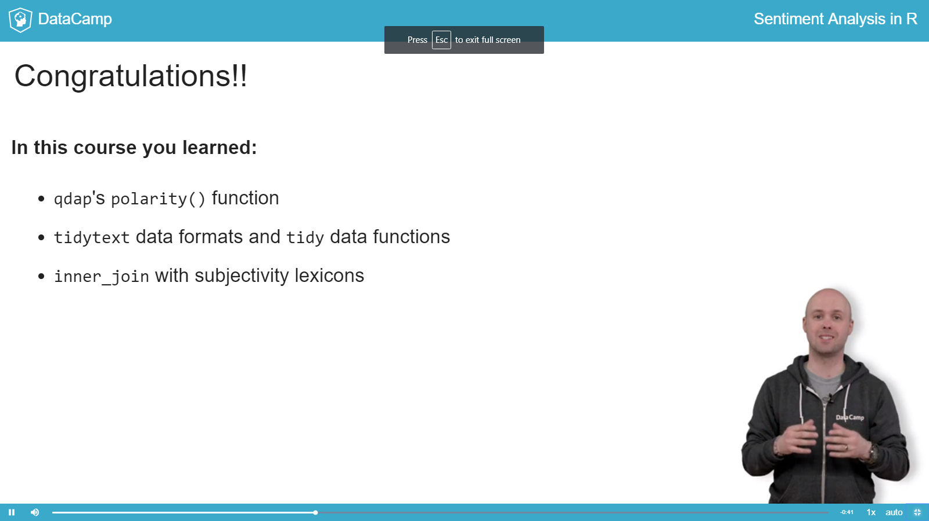

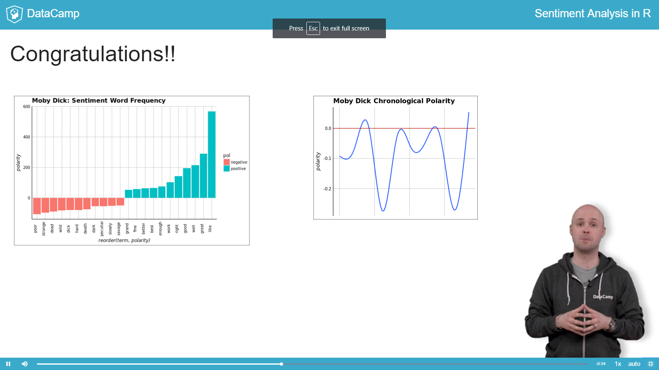

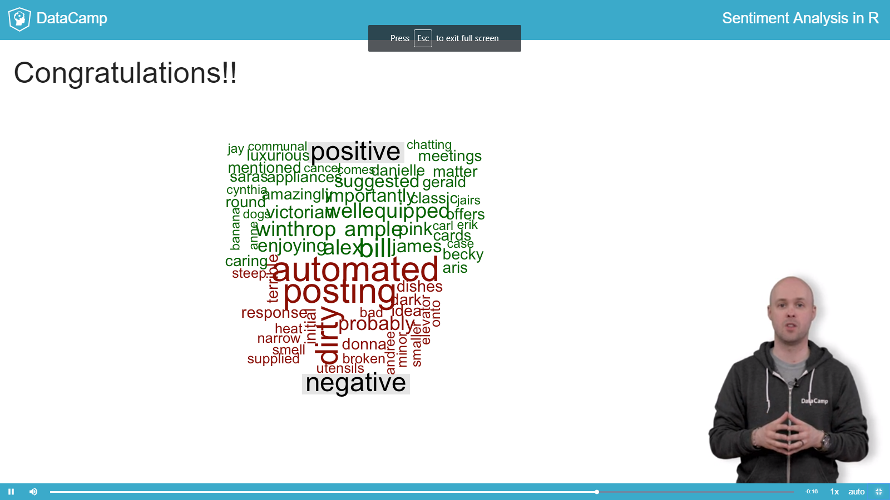

Chapter 2 : 2Sentiment analysis the tidytext way

DTM vs. tidytext matrix
There is a growing number of "tidyverse" R packages. The tidyverse is a collection of R packages that share common philosophies and are designed to work together. This chapter covers some tidy functions to manipulate data. In fact, in this exercise you will compare a DTM to a tidy text data frame called a tibble.
Within the tidyverse each observation is a single row in a data frame. That makes working in different packages much easier since the fundamental data structure is the same. Parts of this course borrow heavily from the tidytextpackage which uses this data organization.
For example, you may already be familiar with the %>% operator from the magrittr package. This forwards an object on its left-hand side as the first argument of the function on its right-hand side.
In the example below, you are forwarding the data object to function1(). Notice how the parentheses are empty. This in turn is forwarded to function2(). In the last function you don't have to add the data object because it was forwarded from the output of function1(). However, you do add a fictitious parameter, some_parameter as TRUE. These pipe forwards ultimately create the object.
object <- data %>%
function1() %>%
function2(some_parameter = TRUE)

To use the %>% operator, you don't necessarily need to load the magrittrpackage, since it is also available in the dplyr package. dplyr also contains the functions inner_join() (which you'll learn more about later) and count() for tallying data. The last function you'll need is mutate() to create new variables or modify existing ones.
object <- data %>%
mutate(new_Var_name = Var1 - Var2)

or to modify a variable
object <- data %>%
mutate(Var1 = as.factor(Var1))

You will also use tidyr's spread() function to organize the data with each row being a line from the book and the positive and negative values as columns.
index | negative | positive
42 | 2 | 0
43 | 0 | 1
44 | 1 | 0
To change a DTM to a tidy format use tidy() from the broom package.
tidy_format <- tidy(Document_Term_Matrix)

This exercise uses text from the Greek tragedy, Agamemnon. Agamemnon is a story about marital infidelity and murder. You can download a copy here.
INSTRUCTIONS
100XP
INSTRUCTIONS
100XP
We've already created a clean DTM called ag_dtm for this exercise.
- Create ag_dtm_m by applying as.matrix() to ag_dtm.
- Using brackets, [ and ], index ag_dtm_m to row 2206.
- Apply tidy() to ag_dtm. Call the new object ag_tidy.
- Examine ag_tidy at rows [831:835, ] to compare the tidy format. You will see a common word from the examined part of ag_dtm_m in step 2.
# As matrix
ag_dtm_m <- as.matrix(ag_dtm)

# Examine line 2206 and columns 245:250
ag_dtm_m[2206, 245:250]

# Tidy up the DTM
ag_tidy <- tidy(ag_dtm)

# Examine tidy with a word you saw
ag_tidy[831:835, ]

Examine the sentiments data frame
So far you have used a single lexicon. Now we will transition to using three, each measuring sentiment in different ways.
The tidytext package contains a data frame called sentiments. The data frame contains over 23000 terms from three different subjectivity lexicons with corresponding information. Here are some example rows from the sentiments data frame.
Word | Sentiment | Lexicon | Score
abhorrent | NA | AFINN | -3
cool | NA | AFINN | 1
congenial | positive | Bing | NA
enemy | negative | Bing | NA
ungrateful | anger | NRC | NA
sectarian | anger | NRC | NA
Notice the tidy format. Each word is a row and NAs fill in columns that are not applicable. The "AFINN" lexicon scores words from 5 to -5. The "Bing" lexicon is the same lexicon used in qdap's polarity() function. "Bing" words are only labeled as positive or negative. The "NRC" lexicon has distinct emotional classes covering Plutchik's Wheel and positive and negative.
Let's explore the sentiments data frame in more detail!
INSTRUCTIONS
100XP
INSTRUCTIONS
100XP
- Use get_sentiments() to obtain the "afinn" lexicon in a new object called afinn_lex.
- Review the overall count() of score in afinn_lex.
- Now get the "nrc" lexicon using get_sentiments(). Call the new object nrc_lex.
- Print nrc_lex to see part of the tibble.
- Forward the nrc_lex object using the %>% operator to count() and specify the sentiment column without quotes. Call the new object nrc_counts.
- Create a barplot by passing nrc_counts into ggplot(). The aesthetics should be aes(x = sentiment, y = n) and add stat = "identity"inside geom_bar().

# Subset to AFINN
afinn_lex <- get_sentiments("afinn")

# Count AFINN scores
afinn_lex %>%
count(score)

# Subset to nrc
nrc_lex <- get_sentiments("nrc")

# Print nrc_lex
nrc_lex

# Make the nrc counts object
nrc_counts <- nrc_lex %>%
count(sentiment)

# Barplot
ggplot(nrc_counts, aes(x = sentiment, y = n))+
geom_bar(stat = "identity") +
theme_gdocs()

Bing tidy polarity: Simple example
The Bing lexicon labels words as positive or negative. The next three exercises let you interact with this specific lexicon. Instead of using filter() to extract a lexicon this exercise uses get_sentiments() which accepts a string such as "afinn", "bing", "nrc", or "loughran".
Now that you understand the basics of an inner join, let's apply this to the "Bing" lexicon. Keep in mind the inner_join() function comes from dplyrand the sentiments object is from tidytext.
The inner join workflow:
- Obtain the correct lexicon using either filter() or get_sentiments().
- Pass the lexicon and the tidy text data to inner_join().
- In order for inner_join() to work there must be a shared column name. If there are no shared column names, declare them with an additional parameter, by equal to c with column names like below.
object <- x %>%
inner_join(y, by = c("column_from_x" = "column_from_y")

- Perform some aggregation and analysis on the table intersection.
INSTRUCTIONS
100XP
INSTRUCTIONS
100XP
We've loaded ag_txt containing the first 100 lines from Agamemnon and ag_tidy which is the tidy version.
- For comparison, use polarity() on ag_txt.
- Get the "bing" lexicon by passing that string to get_sentiments().
  - Perform an inner_join() with ag_tidy and bing.
The word columns are called "term" in ag_tidy and "word" in the lexicon, so you need to specify the by argument.
  - Call the new object ag_bing_words.
- Print ag_bing_words, and look at some of the words that are in the result.
- Pass ag_bing_words to count() of sentiment using the pipe operator, %>%. Compare the polarity() score to sentiment count ratio.

# Qdap polarity
polarity(ag_txt)

# Get Bing lexicon
bing <- get_sentiments("bing")

# Join text to lexicon
ag_bing_words <- inner_join(ag_tidy, bing, by = c("term" = "word"))

# Examine
ag_bing_words

# Get counts by sentiment
ag_bing_words %>%
count(sentiment)

Bing tidy polarity: Count & spread the white whale
In this exercise you will apply another inner_join() using the "bing"lexicon.
Then you will manipulate the results with both count() from dplyr and spread() from tidyr to learn about the text.
The spread() function spreads a key-value pair across multiple columns. In this case key is the sentiment and the values are the frequency of positive or negative terms for each line. Using spread() changes the data so that each row now has positive and negative values, even if it is 0.
INSTRUCTIONS
100XP
In this exercise, your R session has m_dick_tidy which contains the book Moby Dick and bing, containing the lexicon similar to the previous exercise.
  - Perform an inner_join() on m_dick_tidy and bing.
As before, join the "term" column in m_dick_tidy to the "word"column in the lexicon.
  - Call the new object moby_lex_words.
- Create a column index, equal to as.numeric() applied to document. This occurs within mutate() in the tidyverse.
- Create moby_count by forwarding moby_lex_words to count(), passing in sentiment, index.
- Generate moby_spread by piping moby_count to spread() which contains sentiment, n, and fill = 0.
--
# Inner join
moby_lex_words <- inner_join(m_dick_tidy, bing, by = c("term" = "word"))

moby_lex_words <- moby_lex_words %>%
# Set index to numeric document
mutate(index = as.numeric(document))

moby_count <- moby_lex_words %>%
# Count by sentiment, index
count(sentiment, index)

# Examine the counts
moby_count

moby_spread <- moby_count %>%
# Spread sentiments
spread(sentiment, n, fill = 0)

# Review the spread data
moby_spread

Bing tidy polarity: Call me Ishmael (with ggplot2)!
The last Bing lexicon exercise! We started with this lexicon since its similar to the results in Chapter 1. In this exercise you will use the pipe operator (%>%) to create a timeline of the sentiment in Moby Dick. In the end you will also create a simple visual following the code structure below. The next chapter goes into more depth for visuals.
ggplot(spread_data, aes(index_column, polarity_column)) +
geom_smooth()

INSTRUCTIONS
100XP
INSTRUCTIONS
100XP
Your R session has moby as your text and bing as your lexicon. After this exercise you should know Is Moby Dick a happy or sad book?
- Inner join moby to the bing lexicon.
  - Call inner_join() to join the tibbles.
  - Join by the term column in the text and the word column in the lexicon.
- Count by sentiment and index.
- Reshape so that each sentiment has its own column.
  - Call spread().
  - The key column (to split into multiple columns) is sentiment.
  - The value column (containing the counts) is n.
  - Also specify fill = 0 to fill out missing values with a zero.
- Use mutate() to add the polarity column. Define it as the difference between the positive and negative columns.
- Lastly, create a sentiment time series with ggplot().
  - Pass in moby_polarity to the data argument.
  - Then specify the x and y aesthetics, calling aes() and passing index and polarity without quotes.
  - Add a smoothed sentiment curve with geom_smooth().

--
moby_polarity <- moby %>%
# Inner join to lexicon
inner_join(bing, by = c("term" = "word")) %>%
# Count the sentiment scores
count(sentiment, index) %>%
# Spread the sentiment into positive and negative columns
spread(sentiment, n, fill = 0) %>%
# Add polarity column
mutate(polarity = positive - negative)

# Plot polarity vs. index
ggplot(moby_polarity, aes(index, polarity)) +
# Add a smooth trend curve
geom_smooth()

AFINN: I'm your Huckleberry
Now we transition to the AFINN lexicon. The AFINN lexicon has numeric values from 5 to -5, not just positive or negative. Unlike the Bing lexicon's sentiment, the AFINN lexicon's sentiment score column is called score.
As before, you apply inner_join() then count(). Next, to sum the scores of each line, we use dplyr's group_by() and summarize() functions. The group_by() function takes an existing data frame and converts it into a grouped data frame where operations are performed "by group". Then, the summarize() function lets you calculate a value for each group in your data frame using a function that aggregates data, like sum() or mean(). So, in our case we can do something like
data_frame %>%
group_by(book_line) %>%
summarize(total_score = sum(book_line))

In the tidy version of Huckleberry Finn, line 9703 contains words "best", "ever", "fun", "life" and "spirit". "best" and "fun" have AFINN scores of 3 and 4 respectively. After aggregating, line 9703 will have a total score of 7.
In the tidyverse, filter() is preferred to subset() because it combines the functionality of subset() with simpler syntax. Here is an example that filter()s data_frame where some value in column1 is equal to 24. Notice the column name is not in quotes.
filter(data_frame, column1 == 24)

INSTRUCTIONS
100XP
INSTRUCTIONS
100XP
The afinn object contains the AFINN lexicon. The huck object is a tidy version of Mark Twain's Adventures of Huckleberry Finn for analysis.
Line 5400 is All the loafers looked glad; I reckoned they was used to having fun out of Boggs. Stopwords and punctuation have already been removed in the dataset.
- inner_join() huck to the afinn lexicon.
  - Remember huck is already piped into the function so just add the lexicon.
  - Join by the term column in the text and the word column in the lexicon.
  - Use count() with score and line to tally/count observations by group.
Assign the result to huck_afinn.
- Get the total sentiment score by line forwarding huck_afinn to group_by() and passing line without quotes.
  - Create huck_afinn_agg using summarize(), setting total_scoreequal to the sum() of score.
- Use filter() on huck_afinn_agg and line == 5400 to review a single line.
- To create a sentiment timeline ggplot(), pass in huck_afinn_agg to the data argument.
  - Then specify the x and y within aes() as line and total_scorewithout quotes.
  - Add a layer with geom_smooth().

--
# See abbreviated line 5400
huck %>% filter(line == 5400)

# What are the scores of the sentiment words?
afinn %>% filter(word %in% c("fun", "glad"))

huck_afinn <- huck %>%
# Inner Join to AFINN lexicon
inner_join(afinn, by = c("term" = "word")) %>%
# Count by score and line
count(score, line)

huck_afinn_agg <- huck_afinn %>%
# Group by line
group_by(line) %>%
# Sum scores by line
summarize(total_score = sum(score))

# Filter huck_afinn_agg
huck_afinn_agg %>% filter(line == 5400)

# Plot total score vs. line
ggplot(huck_afinn_agg, aes(line, total_score)) +
# Add a smooth trend curve
geom_smooth()

The wonderful wizard of NRC
Last but not least, you get to work with the NRC lexicon which labels words across multiple emotional states. Remember Plutchik's wheel of emotion? The NRC lexicon tags words according to Plutchik's 8 emotions plus positive/negative.
In this exercise there is a new operator, %in%, which matches a vector to another. In the code below %in% will return FALSE, FALSE, TRUE. This is because within some_vec, 1 and 2 are not found within some_other_vector but 3 is found and returns TRUE. The %in% is useful to find matches.
some_vec <- c(1, 2, 3)
some_other_vector <- c(3, "a", "b")
some_vec %in% some_other_vector

Another new operator is !. For logical conditions, adding ! will inverse the result. In the above example, the FALSE, FALSE, TRUE will become TRUE, TRUE, FALSE. Using it in concert with %in% will inverse the response and is good for removing items that are matched.
!some_vec %in% some_other_vector

INSTRUCTIONS
100XP
INSTRUCTIONS
100XP
We've created oz which is the tidy version of The Wizard of Oz along with nrc containing the "NRC" lexicon with renamed columns.
- Inner join oz to the nrc lexicon.
  - Call inner_join() to join the tibbles.
  - Join by the term column in the text and the word column in the lexicon.
  - Assign the result to oz_nrc.
  - Filter to only Pluchik's emotions and drop the positive or negative words in the lexicon.
Use filter() to keep rows where the sentiment is not "positive"or "negative".
- Group by sentiment.
  - Call group_by(), passing sentiment without quotes.
- Get the total count of each sentiment.
  - Call summarize(), setting total_count equal to the sum() of count.
  - Assign the result to oz_plutchik.
- Lastly, create a bar plot with ggplot().
  - Pass in oz_plutchik to the data argument.
  - Then specify the x and y aesthetics, calling aes() and passing sentiment and total_count without quotes.
  - Add a column geom with geom_col(). (This is the same as geom_bar(), but doesn't summarize the data, since you've done that already.)
--
# Join text and lexicon
oz_nrc <- inner_join(oz, nrc, by = c("term" = "word"))

# DataFrame of tally
oz_plutchik <- oz_nrc %>%
# Only consider Plutchik sentiments
filter(!sentiment %in% c("positive", "negative")) %>%
# Group by sentiment
group_by(sentiment) %>%
# Get total count by sentiment
summarize(total_count = sum(count))

# Plot the counts
ggplot(oz_plutchik, aes(x = sentiment, y = total_count)) +
# Add a column geom
geom_col()

CHAPTER 1 :
TM refreshener , DTM , POLARITY

ump right in! Visualize polarity
Sentiment analysis helps you extract an author's feelings towards a subject. This exercise will give you a taste of what's to come!
We created text_df representing a conversation with person and textcolumns.
Use qdap's polarity() function to score text_df. polarity() will accept a single character object or data frame with a grouping variable to calculate a positive or negative score.
In this example you will use the magrittr package's dollar pipe operator %$%. The dollar sign forwards the data frame into polarity() and you declare a text column name or the text column and a grouping variable without quotes.
text_data_frame %$% polarity(text_column_name)

To create an object with the dollar sign operator:
polarity_object <- text_data_frame %$%
polarity(text_column_name, grouping_column_name)

More specifically, to make a quantitative judgement about the sentiment of some text, you need to give it a score. A simple method is a positive or negative value related to a sentence, passage or a collection of documents called a corpus. Scoring with positive or negative values only is called "polarity." A useful function for extracting polarity scores is counts()applied to the polarity object. For a quick visual call plot() on the polarity() outcome.
INSTRUCTIONS
0XP
INSTRUCTIONS
0XP
- Examine the text_df conversation data frame.
- Using %$% pass text_df to polarity() along with the column name text without quotes. This will print the polarity for all text.
- Create a new object datacamp_conversation by forwarding text_df with %$% to polarity(). Pass in text followed by the grouping personcolumn. This will calculate polarity according to each individual person. Since it is all within parentheses the result will be printed too.
- Apply counts() to datacamp_conversation to print the specific emotional words that were found.
- plot() the datacamp_conversation.

HINT
- Type text_df in your console.
- Pass text without quotes to polarity() to get the overall polarity of the text.
- Do the same again, but pass person as a second argument to get the polarity by person.
- Call counts() with datacamp_conversation as the only argument to count the emotional words.
- Likewise, call plot() with datacamp_conversation as the only argument to plot the results.

--
# Examine the text data
text_df

# Calc overall polarity score
text_df %$% polarity(text)

# Calc polarity score by person
(datacamp_conversation <- text_df %$% polarity(text, person))

# Counts table from datacamp_conversation
counts(datacamp_conversation)

# Plot the conversation polarity
plot(datacamp_conversation)

TM refresher (I)
In the Text Mining: Bag of Words course you learned that a corpus is a set of texts, and you studied some functions for preprocessing the text. To recap, one way to create a corpus is with the functions below. Even though this is a different course, sentiment analysis is part of text mining so a refresher can be helpful.
- Turn a character vector into a text source using VectorSource().
- Turn a text source into a corpus using VCorpus().
- Remove unwanted characters from the corpus using cleaning functions like removePunctuation() and stripWhitespace() from tm, and replace_abbreviation() from qdap.
In this exercise a custom clean_corpus() function has been created using standard preprocessing functions for easier application.
clean_corpus() accepts the output of VCorpus() and applies cleaning functions. For example:
processed_corpus <- clean_corpus(my_corpus)

INSTRUCTIONS
100XP
INSTRUCTIONS
100XP
Your R session has a text vector, tm_define, containing two small documents and the function clean_corpus().
- Create an object called tm_vector by applying VectorSource() to tm_define.
- Make tm_corpus using VCorpus() on tm_vector.
- Use content() to examine the contents of the first document in tm_corpus.
  - Documents in the corpus are accessed using list syntax, so use double square brackets, e.g. [[1]].
- Clean the corpus text using the custom function clean_corpus() on tm_corpus. Call this new object tm_clean.
- Examine the first document of the new tm_clean object again to see how the text changed after clean_corpus() was applied.

--
# clean_corpus(), tm_define are pre-defined
clean_corpus
tm_define

# Create a VectorSource
tm_vector <- VectorSource(tm_define)

# Apply VCorpus
tm_corpus <- VCorpus(tm_vector)

# Examine the first document's contents
content(tm_corpus[[1]])

# Clean the text
tm_clean <- clean_corpus(tm_corpus)

# Reexamine the contents of the first doc
content(tm_clean[[1]])

TM refresher (II)
Now let's create a Document Term Matrix (DTM). In a DTM:
- Each row of the matrix represents a document.
- Each column is a unique word token.
- Values of the matrix correspond to an individual document's word usage.
The DTM is the basis for many bag of words analyses. Later in the course, you will also use the related Term Document Matrix (TDM). This is the transpose; that is, columns represent documents and rows represent unique word tokens.
You should construct a DTM after cleaning the corpus (using clean_corpus()). To do so, call DocumentTermMatrix() on the corpus object.
tm_dtm <- DocumentTermMatrix(tm_clean)

If you need a more in-depth refresher check out the Text Mining: Bag of Words course. Hopefully these two exercises have prepared you well enough to embark on your sentiment analysis journey!
INSTRUCTIONS
100XP
INSTRUCTIONS
100XP
We've created a VCorpus() object called clean_text containing 1000 tweets mentioning coffee. The tweets have been cleaned with the previously mentioned preprocessing steps and your goal is to create a DTM from it.
- Apply DocumentTermMatrix() to the clean_text corpus to create a term frequency weighted DTM called tf_dtm .
- Change the DocumentTermMatrix() object into a simple matrix with as.matrix(). Call the new object tf_dtm_m.
- Check the dimensions of the matrix using dim().
- Use square bracket indexing to see a subset of the matrix.
- Select rows 16 to 20, and columns 2975 to 2985
- Note the frequency value of the word "working."
--
# clean_text is pre-defined
clean_text

# Create tf_dtm
tf_dtm <- DocumentTermMatrix(clean_text)

# Create tf_dtm_m
tf_dtm_m <- as.matrix(tf_dtm)

# Dimensions of DTM matrix
dim(tf_dtm_m)

# Subset part of tf_dtm_m for comparison
tf_dtm_m[16:20, 2975:2985]

Where can you observe Zipf's law?
Although Zipf observed a steep and predictable decline in word usage you may not buy into Zipf's law. You may be thinking "I know plenty of words, and have a distinctive vocabulary". That may be the case, but the same can't be said for most people! To prove it, let's construct a visual from 3 million tweets mentioning "#sb". Keep in mind that the visual doesn't follow Zipf's law perfectly, the tweets all mentioned the same hashtag so it is a bit skewed. That said, the visual you will make follows a steep decline showing a small lexical diversity among the millions of tweets. So there is some science behind using lexicons for natural language analysis!
In this exercise, you will use the package metricsgraphics. Although the author suggests using the pipe %>% operator, you will construct the graphic step-by-step to learn about the various aspects of the plot. The main function of the package metricsgraphics is the mjs_plot() function which is the first step in creating a JavaScript plot. Once you have that, you can add other layers on top of the plot.
An example metricsgraphics workflow without using the %>% operator is below:
metro_plot <- mjs_plot(data, x = x_axis_name, y = y_axis_name, show_rollover_text = FALSE)
metro_plot <- mjs_line(metro_plot)
metro_plot <- mjs_add_line(metro_plot, line_one_values)
metro_plot <- mjs_add_legend(metro_plot, legend = c('names', 'more_names'))
metro_plot

INSTRUCTIONS
100XP
INSTRUCTIONS
100XP
- Use head() on sb_words to review top words.
- Create a new column expectations by dividing word frequency, freq, by the rank column.
- Start sb_plot using mjs_plot().
  - Pass in sb_words with x = rank and y = freq.
  - Within mjs_plot() set show_rollover_text to FALSE.
- Overwrite sb_plot using mjs_line() and pass in sb_plot.
  - Add to sb_plot with mjs_add_line().
Pass in the previous sb_plot object and the vector, expectations.
  - Place a legend on a new sb_plot object using mjs_add_legend().
Pass in the previous sb_plot object
  - The legend labels should consist of "Frequency" and "Expectation".
- Call sb_plot to display the plot. Mouseover a point to simultaneously highlight a freq and Expectation point. The magic of JavaScript!

--
# Examine sb_words
head(sb_words)

# Create expectations
sb_words$expectations <- sb_words %$%
{freq / rank}

# Create metrics plot
sb_plot <- mjs_plot(sb_words, x = rank, y = freq, show_rollover_text = FALSE)

# Add 1st line
sb_plot <- mjs_line(sb_plot)

# Add 2nd line
sb_plot <- mjs_add_line(sb_plot, expectations)

# Add legend
sb_plot <- mjs_add_legend(sb_plot, legend = c("Frequency", "Expectation"))

# Display plot
sb_plot

Polarity on actual text
So far you have learned the basic components needed for assessing positive or negative intent in text. Remember the following points so you can feel confident in your results.
- The subjectivity lexicon is a predefined list of words associated with emotions or positive/negative feelings.
- You don't have to list every word in a subjectivity lexicon because Zipf's law describes human expression.
A quick way to get started is to use the polarity() function which has a built-in subjectivity lexicon.
The function scans the text to identify words in the lexicon. It then creates a word group around the identified positive or negative subjectivity word. Within the group valence shifters adjust the score. Valence shifters are words that amplify or negate the emotional intent of the subjectivity word. For example, "well known" is positive while "not well known" is negative. Here "not" is a negating term and reverses the emotional intent of "well known." In contrast, "very well known" employs an amplifier increasing the positive intent.
The polarity() function then calculates a score using subjectivity terms, valence shifters and the total number of words in the passage. This exercise demonstrates a simple polarity calculation. In the next video we look under the hood of polarity() for more detail.
INSTRUCTIONS
0XP
INSTRUCTIONS
0XP
We've defined positive to denote a positive statement.
- Calculate the polarity() of positive in a new object called pos_score. Encase the entire call in parentheses so the output is also printed.
- Get a word count object by calling counts() on the polarity object.
- All the identified subjectivity words are part of count object's list. Specifically, positive words are in $pos.words element vector. Find the number of positive words in n_good by calling length() on the first part of the $pos.words element.
- Capture the total number of words and assign it to n_words. This value is stored in pos_count as the wc element.
- Deconstruct the polarity() calculation by dividing n_good by sqrt()of n_words. Compare the result to pos_pol to the equation's result.

HINT
- Call polarity() on the text to get the polarity.
- Call counts() on the polarity obejct to get the word count object.
- Use length(pos_counts$pos.words[[1]]) to get the number of positive words.
- Use pos_counts$wc to get the word count.
- The polarity is given by n_good / sqrt(n_words).

# Example statements
positive <- "DataCamp courses are good for learning"

# Calculate polarity of both statements
(pos_score <- polarity(positive))

# Get counts
(pos_counts <- counts(pos_score))

# Number of positive words
n_good <- length(pos_counts$pos.words[[1]])

# Total number of words
n_words <- pos_counts$wc

# Verify polarity score
n_good / sqrt(n_words)

Happy songs!
Of course just positive and negative words aren't enough. In this exercise you will learn about valence shifters which tell you about the author's emotional intent. Previously you applied polarity() to text without valence shifters. In this example you will see amplifers and negating words in action.
Recall that an amplifying word adds 0.8 to a positive word in polarity() so the positive score becomes 1.8. For negative words 0.8 is subtracted so the total becomes -1.8. Then the score is divided by the square root of the total number of words.
Consider the following example from Frank Sinatra:
- "It was a very good year"
"Good" equals 1 and "very" adds another 0.8. So, 1.8/sqrt(6) results in 0.73 polarity.
A negating word such as "not" will inverse the subjectivity score. Consider the following example from Bobby McFerrin:
- "Don't worry Be Happy"
"worry is now 1 due to the negation "don't." Adding the "happy", +1, equals 2. With 4 total words, 2 / sqrt(4) equals a polarity score of 1.
INSTRUCTIONS
100XP
INSTRUCTIONS
100XP
- Examine the conversation data frame,conversation. Note the valence shifters like "never" in the text column.
- Apply polarity() to the text column of conversation to calculate polarity for the entire conversation.
- Calculate the polarity scores by student, assigning the result to student_pol.
  - Call polarity() again, this time passing two columns of conversation.
  - The text variable is text and the grouping variable is student.
- To see the student level results, use scores() on student_pol.
- The counts() function applied to student_pol will print the sentence level polarity for the entire data frame along with lexicon words identified.
- The polarity object, student_pol, can be plotted with plot().

--
# Examine conversation
conversation

# Polarity - All
polarity(conversation$text)

# Polarity - Grouped
student_pol <- conversation %$%
polarity(text, student)

# Student results
scores(student_pol)

# Sentence by sentence
counts(student_pol)

# qdap plot
plot(student_pol)
-------------------

LOL, this song is wicked good
Even with Zipf's law in action, you will still need to adjust lexicons to fit the text source (for example twitter versus legal documents) or the author's demographics (teenage girl versus middle aged man). This exercise demonstrates the explicit components of polarity() so you can change it if needed.
In Trey Songz "Lol :)" song there is a lyric "LOL smiley face, LOL smiley face." In the basic polarity() function, "LOL" is not defined as positive. However, "LOL" stands for "Laugh Out Loud" and should be positive. As a result, you should adjust the lexicon to fit the text's context which includes pop-culture slang. If your analysis contains text from a specific channel (Twitter's "LOL"), location (Boston's "Wicked Good"), or age group (teenagers "sick") you will likely have to adjust the lexicon.
In this exercise you are not adjusting the subjectivity lexicon or qdapdictionaries containing valence shifters. Instead you are examining the existing word data frame objects so you can change them in the following exercise.
INSTRUCTIONS
100XP
INSTRUCTIONS
100XP
We've created text containing two excerpts from Beyoncé's "Crazy in Love" lyrics for the exercise.
- Print key.pol to see a portion of the subjectivity words and values.
- Examine the predefined negation.words to print all the negating terms.
- Now print the amplification.words to see the words that add values to the lexicon.
- Check the deamplification.words to print the words that reduce the lexicon values.
- Call text to see conversation.
- Calculate polarity() as follows.
  - Set text.var to text$words.
  - Set grouping.var to text$speaker.
  - Set polarity.frame to key.pol.
  - Set negators to negation.words.
  - Set amplifiers to amplification.words.
  - Set deamplifiers to deamplification.words.

--
# Examine the key.pol
key.pol

# Negators
negation.words

# Amplifiers
amplification.words

# De-amplifiers
deamplification.words

# Examine
text

# Explicit polarity parameters
polarity(
text.var = text$words,
grouping.var = text$speaker,
polarity.frame = key.pol,
negators = negation.words,
amplifiers = amplification.words,
deamplifiers = deamplification.words
)

Stressed Out!
Here you will adjust the negative words to account for the specific text. You will then compare the basic and custom polarity() scores.
A popular song from Twenty One Pilots is called "Stressed Out". If you scan the lyrics of this song, you will observe the song is about youthful nostalgia. Overall, most people would say the polarity is negative. Repeatedly the lyrics mention stress, fears and pretending.
Let's compare the song lyrics using the default subjectivity lexicon and also a custom one.
To start, you need to verify the key.pol subjectivity lexicon does not already have the term you want to add. One way to check is with grep(). The grep() function returns the row containing characters that match a search pattern. Here is an example used while indexing.
data_frame[grep("search_pattern", data_frame$column), ]

After verifying the slang or new word is not already in the key.pol lexicon you need to add it. The code below uses sentiment_frame() to construct the new lexicon. Within the code sentiment_frame() accepts the original positive word vector, positive.words. Next, the original negative.wordsare concatenated to "smh" and "kappa", both considered negative slang. Although you can declare the positive and negative weights, the default is 1 and -1 so they are not included below.
custom_pol <- sentiment_frame(positive.words, c(negative.words, "hate", "pain"))

Now you are ready to apply polarity and it will reference the customsubjectivity lexicon!
INSTRUCTIONS
100XP
INSTRUCTIONS
100XP
We've created stressed_out which contains the lyrics to the song "Stressed Out", by Twenty One Pilots.
- Use polarity() on stressed_out to see the default score.
- Check key.pol for any words containing "stress". Use grep() to index the data frame by searching in the x column.
  - Create custom_pol as a new sentiment data frame.
Call sentiment_frame() and pass positive.words as the first argument without concatenating any new terms.
  - Next, use c() to combine negative.words with new terms "stressed"and "turn back".
- Reapply polarity() to stressed_out with the additional parameter polarity.frame = custom_pol to compare how the new words change the score to a more accurate representation of the song.

--
# stressed_out has been pre-defined
head(stressed_out)

# Basic lexicon score
polarity(stressed_out)

# Check the subjectivity lexicon
key.pol[grep("stress", x)]

# New lexicon
custom_pol <- sentiment_frame(positive.words, c(negative.words, "stressed", "turn back"))

# Compare new score
polarity(stressed_out, polarity.frame = custom_pol)

